**PL ASSIGNMENT 7B**

**Name:- Aditya Zade**

**PRN:- 2018BTECS00111**

GitHub :- https://github.com/AdityaZade/PL3_Practicals

**Problem Statement 1:-**

Website :-

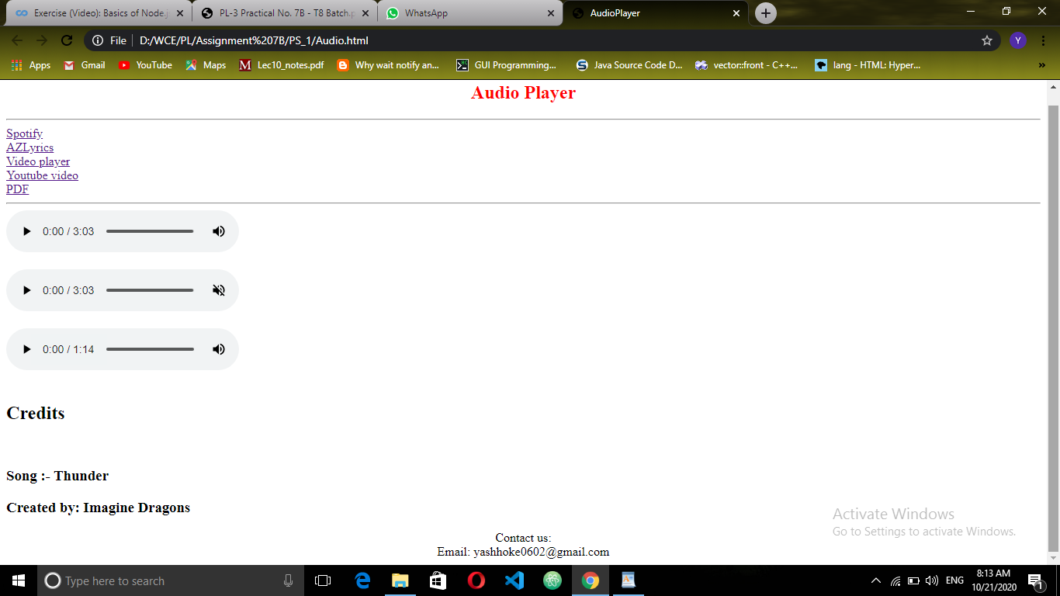

Code :-

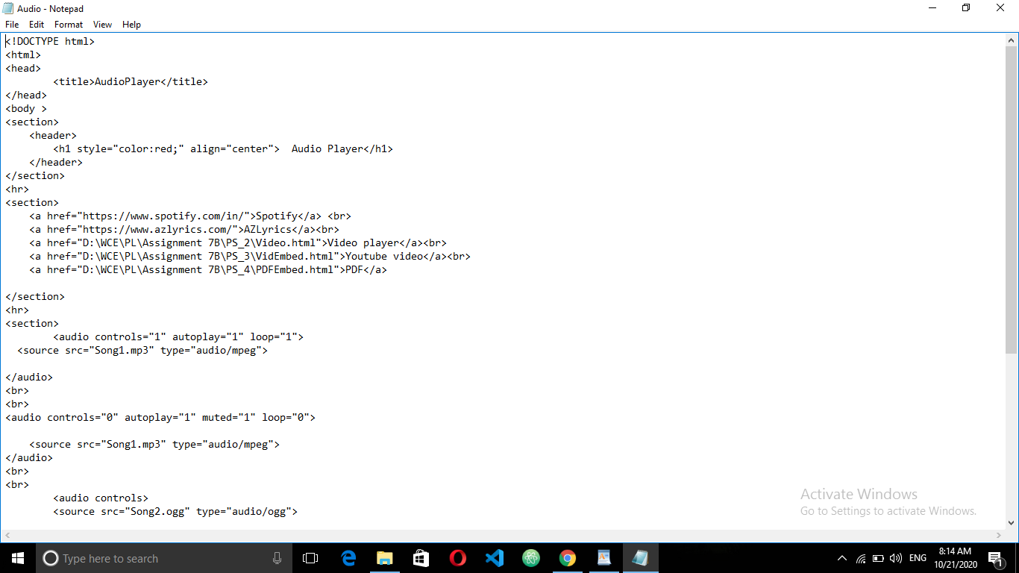

Hosting on Xampp :-

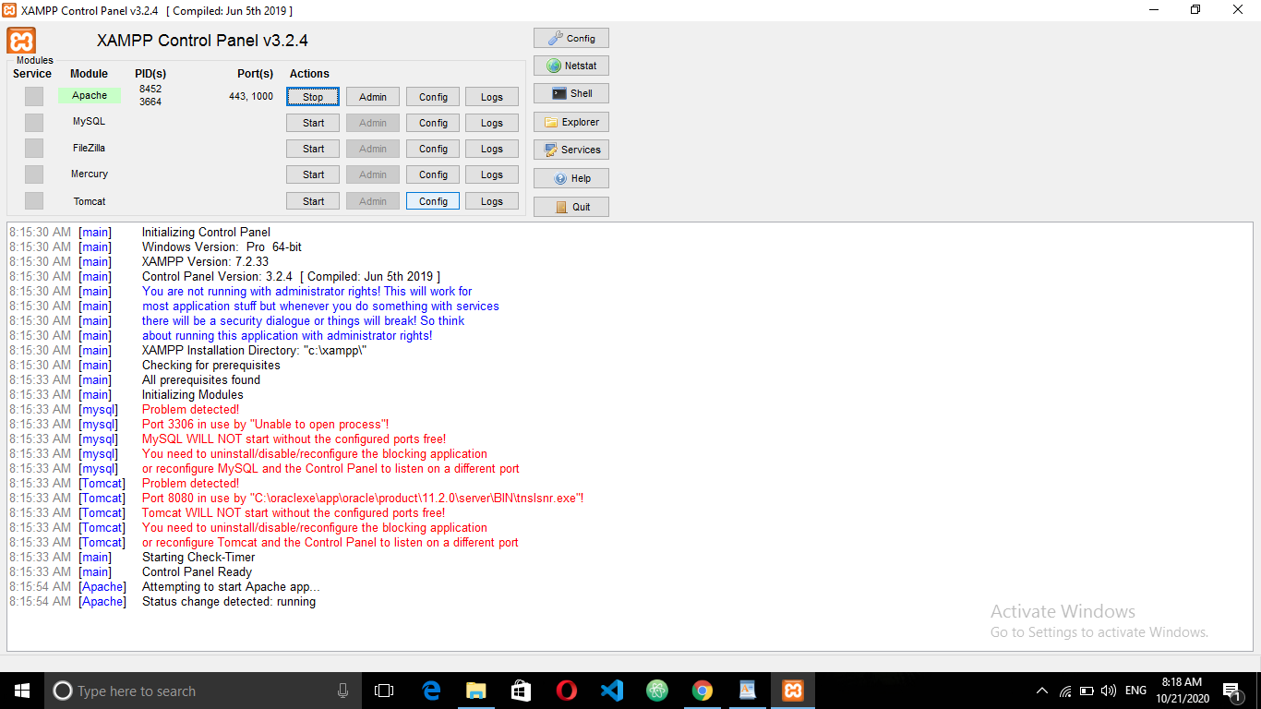

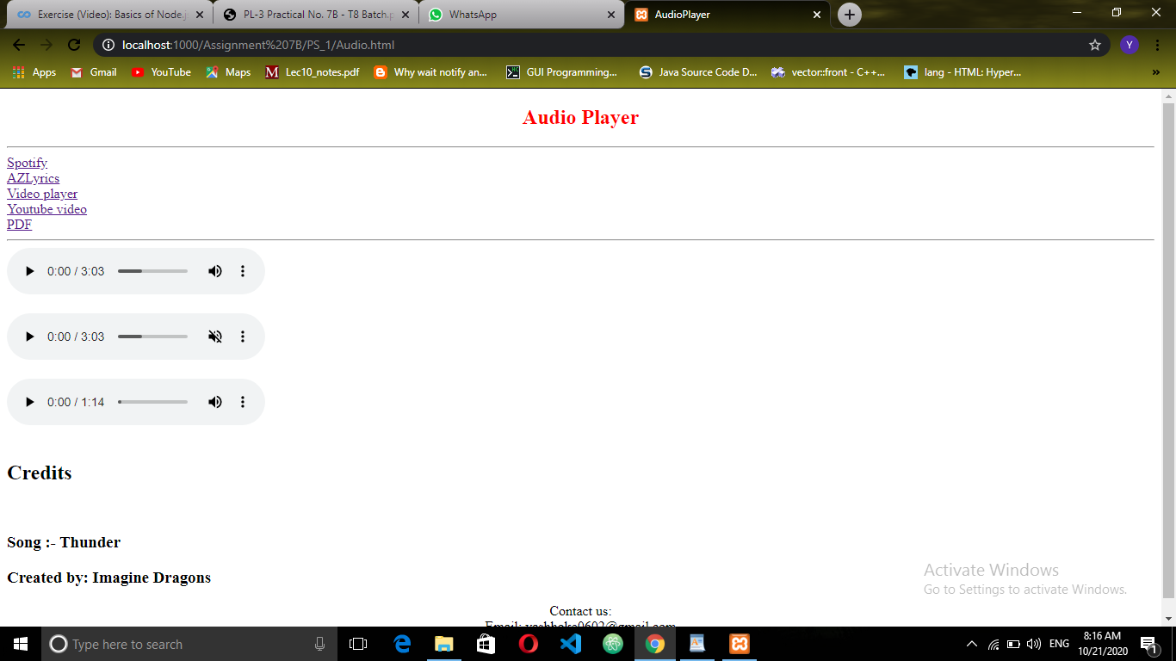

**Problem Statement 2:-**

Website :-

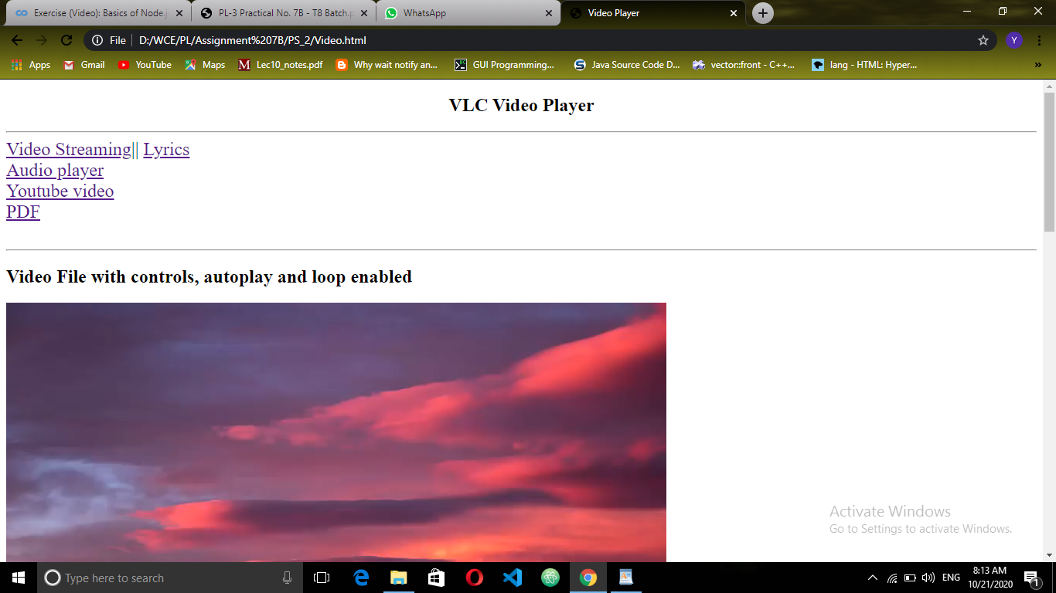

Code :-

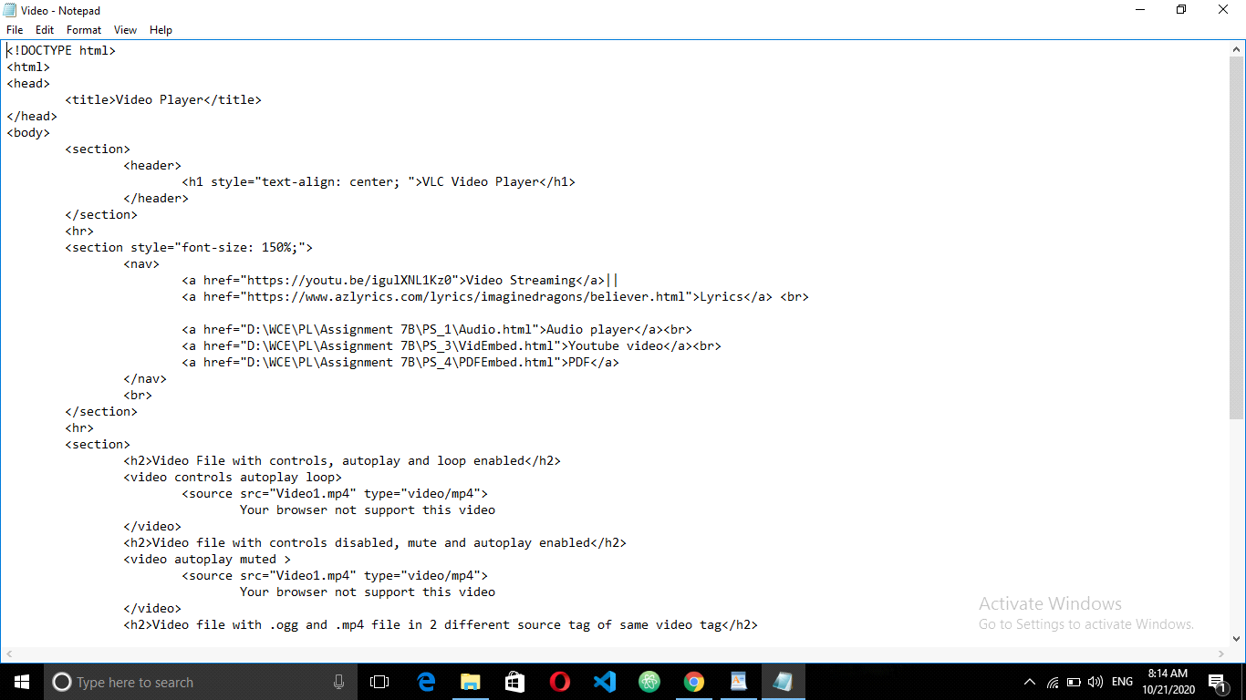

Hosting on Xampp :-



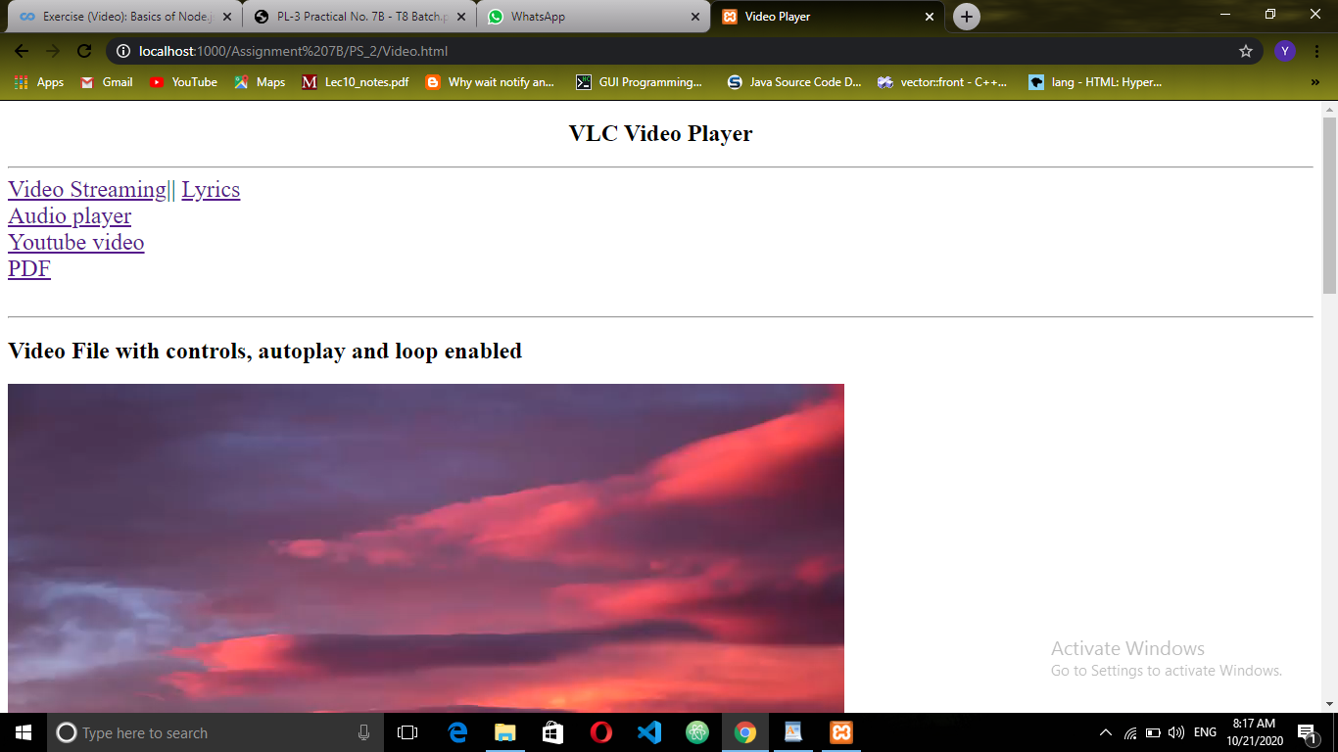

**Problem Statement 3:-**

Website :-

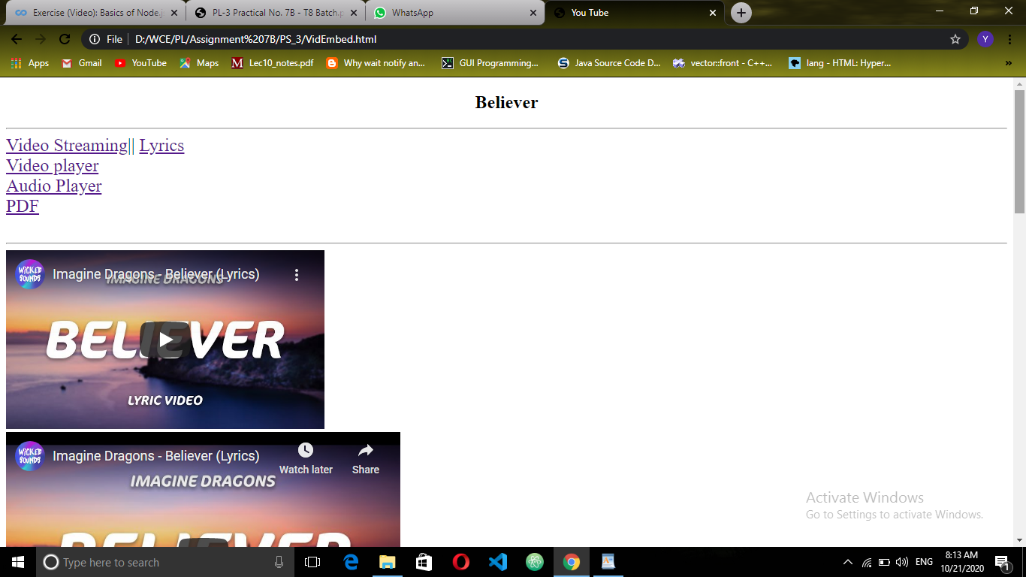

Code :-

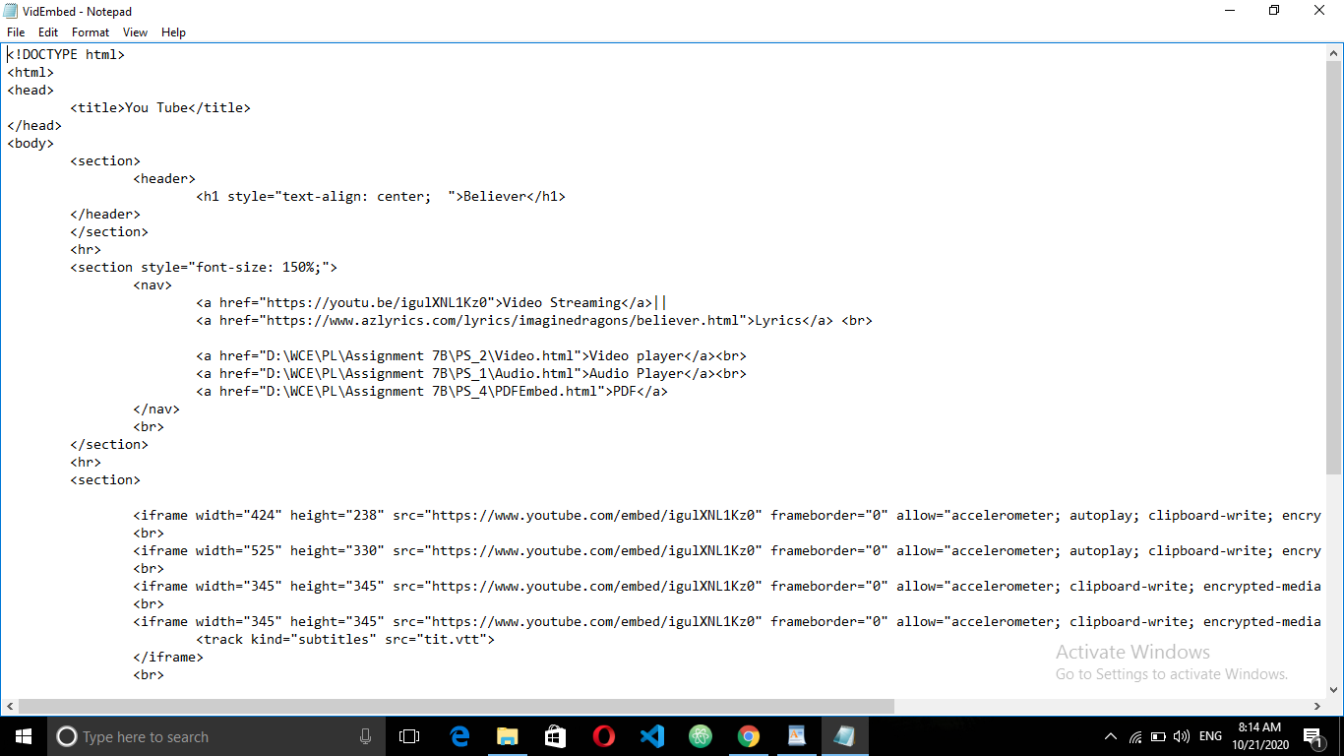

Hosting on Xampp :-



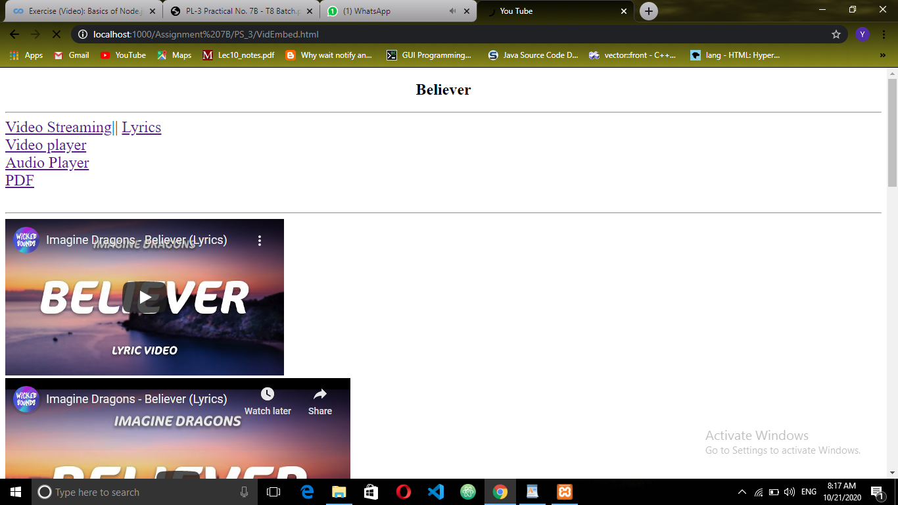

**Problem Statement 4:-**

Website :-

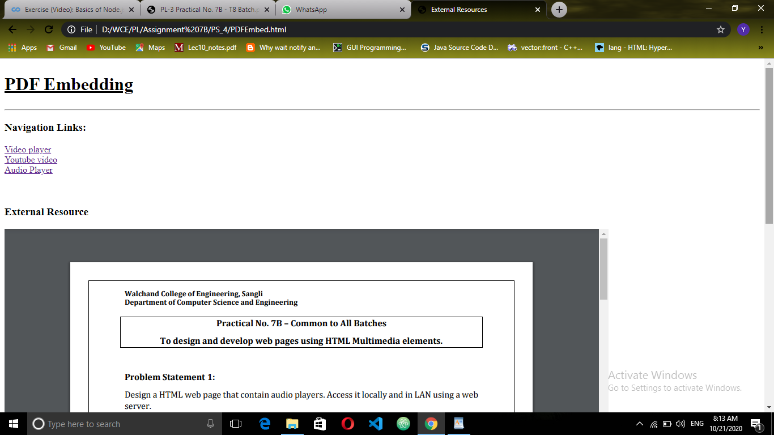

Code :-

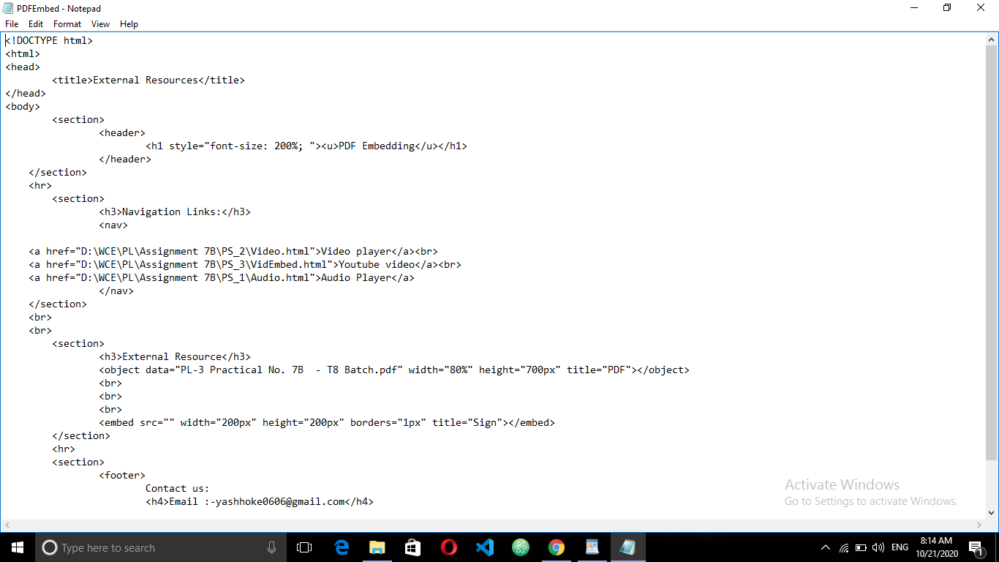

Hosting on Xampp :-

